|  |  |
| --- | --- |
|  | |
| **Texture2Par User’s Guide: A Parameterization Utility for IWFM and MODFLOW, Version 1.0.0** | |
| **Work Conducted Under:** | DWR Contract No. 4600012147 |
| **Technical Work Completed by:** | Leland Scantlebury, Vivek Bedekar, Marinko Karanovic, Matthew J. Tonkin (S.S. Papadopulos & Associates, Inc.), Timothy Durbin (Timothy J. Durbin, Inc.) |
| **Technical Work Reviewed by:** | Linda Bond, Chris Bonds, Tyler Hatch (Department of Water Resources), Mesut Cayar, Sercan Ceyhan, Frank Qian, Saquib Najmus (Woodard & Curran), Claire Velayas (Timothy J. Durbin, Inc.) |
| **Date:** | November 9, 2022 |

**Preface**

This report describes a model parameterization utility called Texture2Par, which calculates values for aquifer parameters on the basis of sediment texture and creates input files for the numerical simulators IWFM and MODFLOW. This report is intended as a user’s guide for modelers. Although an overview is provided of the mathematical methods that Texture2Par uses to translate sediment texture data into values for bulk aquifer parameters, users are advised to familiarize themselves with the references provided at the end of this report to obtain a greater understanding of the approach, its basis, and its limitations. This is particularly relevant to the specification of plausible parameter values for coarse-grained and fine-grained materials; understanding the role and effect of the power law exponents that occur in the empirical relationships used to derive bulk property values; and how these inputs can be used together to reflect contrasting textural, depositional, and other hydro-stratigraphical characteristics of the groundwater system.

***Suggested Citation:***

*Scantlebury, L., V. Bedekar, M. Karanovic, M. J. Tonkin, T. J. Durbin. 2022. Texture2Par User’s Guide: A Parameterization Utility for IWFM and MODFLOW*. *Version 1.0.0.*

Contents

Figures iii

Tables iii

Executive Summary 1

Overview 3

Background 3

Purpose & Scope 4

Software Compatibility 5

Texture2Par 5

Disclaimer 5

IWFM 5

MODFLOW 5

Methodology 6

Texture Interpolation 7

Aquifer Parameter Calculations 11

Hydraulic Properties for Coarse and Fine Materials and Use of Pilot Points 14

Assumptions, Limitations, and Plans for Future Developments 15

Input Instructions for Texture2Par 18

Main Input File 18

Well Log Input File 25

Hydrogeologic Unit Input File 26

IWFM-Specific Input Instructions 26

IWFM Input Files 26

IWFM Pilot Point Zone Input File 27

IWFM Output 27

IWFM Limitations 28

MODFLOW-Specific Input Instructions 28

MODFLOW Input Files 28

MODFLOW Pilot Point Zone Input File 29

Aquitard Support – Quasi-3D Confining Beds 30

MODFLOW Output 30

MODFLOW Limitations 31

Executing Texture2Par 32

Parameter Estimation with Texture2Par 33

Texture2Par and PEST 34

References 38

Figures

Figure 1 - Flowchart Detailing the Methodology of Texture2Par 6

Figure 2 – Map Showing the Geographic Extents of River, Basin, and Alluvial-Fan Deposits of the Surficial Deposits Within the Sacramento Valley. Sources: Helley and Harwood (1985), Mulder (2015), Wagner et. al. (1981, 1982, and 1991), and National Resources Conservation Service (2016). 8

Figure 3 – Example of Lithological Log Intervals, Binary Texture Classifications for Each Interval (Coarse-Grained = 1, Fine-Grained=0), Division by Model Layer and Calculation of Percent Coarse Texture for Each Layer. 10

Figure 4 - Example Hydraulic Conductivity Depth Decay 12

Figure 5 - Example Aquifer Parameter Variation with Percent Coarse. Values for the power law averaging empirical *p* parameter are identical to those used in C2VSim. Note the hydraulic conductivity figures (left side) both have logarithmic y-axes. 13

Figure 6 - Example Texture2Par Main Input File for IWFM Models 19

Figure 7 - Example Texture2Par Main Input File for MODFLOW Models 20

Figure 8 - Excerpt from an Example Well Log Input File with the Hydrogeological Units Specified for Three Layers (Last Three Columns) 25

Figure 9 - Excerpt from Example Hydrogeologic Unit Input Files for MODFLOW (left) and IWFM (right). 26

Figure 10 - Example MODFLOW Pilot Point Zones Input File 29

Figure 11 - Simplified Parameter Estimation Workflow 33

Figure 12 - Example Texture2Par (IWMF) PEST Template File 36

Figure 13 - Example Batch Files for IWFM (Top) and MODFLOW (Bottom) for Running Texture2Par with PEST 37

Tables

Table 1 - Optional Output Files for IWFM Flow Models 28

Table 2 - Optional Output Files for MODFLOW Flow Models 31

# Executive Summary

Texture2Par is a software program developed to generate spatially distributed parameter inputs for numerical groundwater flow models by constructing a three-dimensional hydrogeological model of the aquifer system on the basis of sediment texture information.

This initial version of the Texture2Par program can be used to calculate values for the hydraulic parameters of unconsolidated or loosely consolidated aquifers based on the following three factors:

* The three-dimensional spatial distribution of data describing the percentage of coarse-grained and fine-grained materials – i.e., texture information – throughout the groundwater system;
* Estimated hydraulic properties for “end-member” coarse-grained and fine-grained materials; and
* Empirical parameters that can be used to reflect contrasting textural, depositional, and other hydro-stratigraphical characteristics of the groundwater system as embodied in the conceptual site model (CSM).

The method used by Texture2Par establishes empirical relationships between the texture of unconsolidated and loosely consolidated sediments and bulk aquifer properties to generate values for the following throughout the domain of a numerical groundwater flow model:

* Horizonal hydraulic conductivity
* Vertical hydraulic conductivity
* Specific yield
* Specific storage

Texture2Par uses as input sediment texture data obtained, for example, during the drilling of a well or completion of other borings. Variations in the sediment texture express aspects of the heterogeneity within the aquifer. Texture2Par also incorporates a single-parameter depth-decay function that describes the potential for hydraulic conductivity values to decrease with increasing depth below ground surface due to the effects of compaction resulting from overburden stresses.

Coarse-grained and fine-grained materials are ascribed parameter values and Texture2Par calculates hydraulic conductivity, specific storage, and specific yield at the discretization scale of a numerical model using power law averaging between corresponding values for course-grained and fine-grained materials and the percentage of coarse- and fine-grained materials. The use of these data and relationships can greatly reduce the time and computational cost needed to calculate aquifer parameters while still honoring the available texture data.

The model simulation codes that are supported include the Integrated Water Flow Model (IWFM) and MODFLOW. For every model node (IWFM) or model cell (MODFLOW), Texture2Par calculates bulk (effective) aquifer parameters and writes new input files for the corresponding model. While these parameters can immediately be used as an input to numerical models, they can also serve as a good starting point for calibration. Texture2Par was developed in the Fortran programming language and the program can be used as a standalone utility or seamlessly integrated into the modeling workflow as a pre-processor utility to generate input files for a numerical model. The input files needed by Texture2Par are simple ASCII text files that can be integrated with calibration software such as PEST.

Sediment parameter values are likely spatially variable due to distinct regional characteristics and depositional patterns, such as compaction with depth and geologic source material. This variability can be leveraged through the placement of “pilot points” throughout the model domain as part of model calibration within PEST. By interpolating parameter values between the pilot points using kriging, a minimal number of input parameters, i.e., the hydraulic properties of the coarse-grained and fine-grained materials, need to be estimated during calibration and can be used to describe and control the relationships over the entire model domain. Texture2Par provides flexibility to enter different sediment parameters for different pilot points to represent spatial variability. Pilot points can be grouped with specific model nodes/cells to define regional subareas that exhibit similar ranges of aquifer parameter values or alternatively a single pilot point value may be used when spatial variability of texture data is not required.

This documentation details the method, general workflow, data and file requirements, program execution, and output structures, for the use of Texture2Par in both forward and inverse modeling contexts.

# Overview

## Background

The Central Valley aquifer system in California is predominantly comprised to great depths of unconsolidated sands, gravels and finer sediment facies. The hydraulic properties of the Central Valley aquifer system are related to the texture of these materials. The term “texture” in this context can refer to many characteristics of the materials, including relative coarseness, sorting, sphericity, and roundness, among others. For purposes of Texture2Par, consideration is given only to the relative coarseness of aquifer materials, under the assumption that the other characteristics are less determinative of aquifer properties or are sufficiently correlated with relative coarseness that they can be neglected in studies of the scale of an entire aquifer system. This assumption is consistent with the work of Laudon and Belitz (1989) who defined texture as the percentage of coarse-grained material within a specified subsurface depth interval.

Davis et al. (1959; 1964) were among the first to extensively study the texture of the Central Valley sedimentary deposits. Aspects of the consideration of texture data in developing bulk aquifer properties in California basins are also described in the U.S. Geological Survey (USGS) Water-Resources Investigations Report 78-113 (Durbin et al., 1978). Use of the percentage of coarse-grained deposits, or *texture*, as a basis for determining bulk aquifer parameters is also detailed by Page (1983, 1986), Laudon and Belitz (1991), and Burow et al. (2004). Laudon and Belitz (1989), among others, have used texture data as a primary data source for mapping Central Valley sedimentary deposits. Most such studies rely upon lithologic data obtained from drillers’ logs, which are sometimes assumed to be poor sources of lithologic information. However, studies such as those conducted by Laudon and Belitz (1991) showed that logs obtained via drilling can provide valuable texture information if the data are processed and qualified appropriately. Beyond the spatial mapping of materials, texture data have also been used in a variety of ways to delineate and inform the estimation of aquifer parameters in groundwater models. Published studies demonstrating the use of texture data in this context include those by Phillips and Belitz (1991), Faunt et al. (2010), and Bond and Durbin (2018), although many practitioners have used texture data without necessarily publishing their work.

In recent years substantial effort has been expended by the USGS, California Department of Water Resources (DWR) and other agencies and groups to compile, evaluate, and document in a consistent manner lithologic data – with emphasis on material texture and specifically the percent of coarse materials – throughout the Central Valley. For example, Faunt et al. (2010) describes a three-dimensional (3D) texture model developed to help characterize the Central Valley aquifer sediments. That texture model was developed by compiling and analyzing about 8,500 drillers’ logs, describing lithologies down to a depth of 950 meters (m) (about 3,100 feet [ft]) below land surface. Lithologic descriptions were simplified into a binary classification of coarse- and fine-grained materials. The percentage of coarse-grained material was then estimated for each 15-m depth interval. The texture distribution of the model correlates to the hydraulic properties of independently mapped geologic and geomorphic features of the Central Valley aquifer system, thus demonstrating in a qualitative sense the utility of texture data.

Lithologic data compiled and documented as part of the Faunt et al. (2010) study were publicly released, which has facilitated further review, processing, and augmentation with additional texture data, and thus incorporation of texture data into groundwater modeling studies. Such work has been undertaken by the DWR, among others, in support of modeling studies throughout the Central Valley. In particular, Bond and Durbin (2018) describe the compilation, review, augmentation, and analysis of texture data throughout the Sacramento Valley region of the Central Valley that is encompassed by the Sacramento Valley Simulation (SVSim) and the Fine Grid California Central Valley Groundwater-Surface Water Simulation Model (C2VSimFG) applications of the IWFM code. Texture2Par builds upon the methodology.

## Purpose & Scope

The primary purpose of Texture2Par is to provide groundwater professionals a simple tool to generate 3D aquifer parameter input data for developing numerical models. This document provides an overview of the methods utilized by Texture2Par and provides the user’s manual to facilitate the incorporation of the program into groundwater modeling projects.

# Software Compatibility

## Texture2Par

Texture2Par is a Windows application that can be downloaded in either a 32- or 64-bit version. Texture2Par was developed in the Fortran programming language. The source code is made available so that other operating systems (such as Linux) can be supported by compiling the program on that operating system. Some source code modifications may be necessary to make the code compatible with that operating system and/or compiler. Downloadable versions of Texture2Par are compiled using the Intel® Fortran Compiler Classic 2021.7.1. S.S. Papadopulos & Associates Inc. (SSP&A) offers limited support for the application of Texture2Par on Windows operating systems, but does not currently offer support for the creation, compilation, or application of Texture2Par upon other operating systems or using non-Intel compilers.

## Disclaimer

The performance and accuracy of Texture2Par has been tested with a variety of different simulations, including synthetic models examining the various calculations individually. However, SSP&A makes no representations or warranties with respect to the contents hereof and specifically disclaim any implied warranties of fitness for any particular purpose. The authors provide no warranty, expressed or implied, as to the accuracy or functionality of Texture2Par and its associated outputs. Furthermore, SSP&A reserves the right to revise this publication and software, and to make changes from time to time in the content hereof without obligation to notify any person of such revisions or changes. For updates to Texture2Par and this manual, the software web page should be checked periodically.

## IWFM

Texture2Par was originally developed for application, and tested, with IWFM Version 2015.0 (Dogrul et al., 2018). Limitations regarding the implementation and setup of Texture2Par with models constructed using the IWFM simulation code are documented within the IWFM Limitations section.

## MODFLOW

Texture2Par was modified for application, and tested, with MODFLOW-2000, MODFLOW-2005, and MODFLOW-NWT (Harbaugh, 2005; Harbaugh et al., 2000; Niswonger et al., 2011). Limitations regarding implementation and setup of Texture2Par with models constructed using these simulation codes are documented within the MODFLOW Limitations section. For support in using Texture2Par with another version of MODFLOW, please contact SSP&A at [models@sspa.com](mailto:models@sspa.com).

# Methodology

This chapter covers the methodology employed within Texture2Par to calculate bulk aquifer parameter values at model nodes, in the case of an IWFM model, or model cells, in the case of a MODFLOW model. The distribution of texture (coarseness) developed from lithologic log data to nodes or cells of the model is performed within Texture2Par. The hydraulic properties of the coarse-grained and fine-grained materials are needed as an input for Texture2Par, however when using Texture2Par for model development and calibration, it is recommended that the initial set of hydraulic properties and the range of allowable values that define coarse-grained and fine-grained materials be empirically determined external to this program. Similarly, it is recommended that the empirical parameters that reflect the depositional structure and conceptual model of the groundwater system be developed external to this program and not determined solely as a calibration parameter. Significant work and professional judgement are needed to determine the initial values and range of values for the hydraulic properties of coarse-grained and fine-grained materials and the empirical parameters that reflect the depositional structure.

Methods employed to estimate initial Texture2Par input parameters are detailed in Bond and Durbin (2018). A flow chart of the Texture2Par’s processes is shown in Figure 1. The method for describing the calculation of aquifer parameters is described next in the order it is performed within Texture2Par.

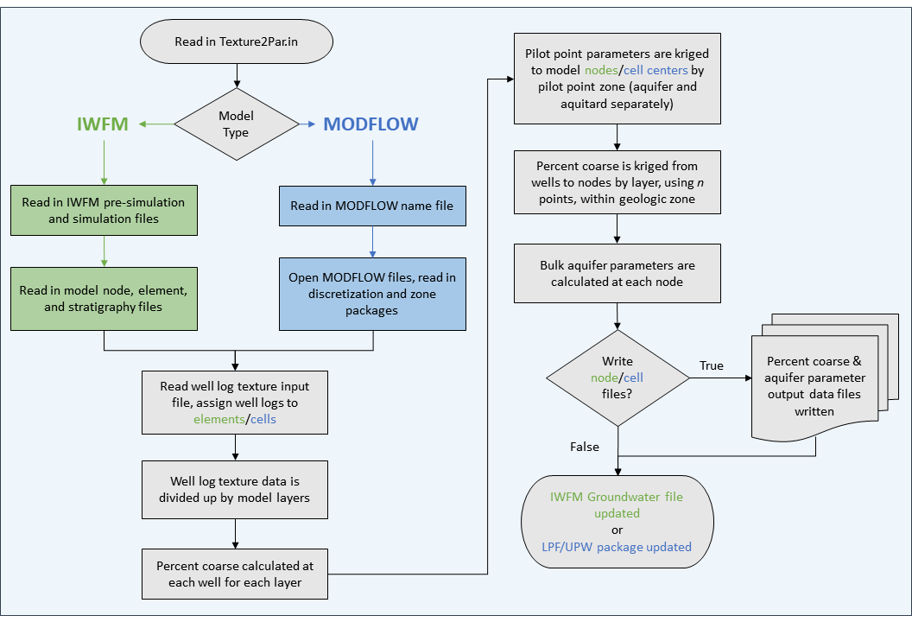

Figure 1 - Flowchart Detailing the Methodology of Texture2Par

## Texture Interpolation

Texture data are based on an analysis of well or boring logs (“wells”), which provide a record of lithologies penetrated during drilling. The analysis consists of simplifying the lithologic descriptions into a binary classification of coarse- and fine-grained materials for each depth interval penetrated (e.g., Laudon and Belitz, 1989). A fine-grained interval is designated a 0, representing zero-percent coarse-grained materials. Conversely, a coarse-grained interval is designated a 1, representing 100-percent coarse-grained materials. Texture values can be determined from written descriptions in lithological logs or resistivity values from geophysical logs (Page, 1986). The DWR maintains a large database of California well logs (as Well Completion Reports) that can be used to create a texture model. In California, anyone who constructs, alters, or destroys a water well, cathodic protection well, groundwater monitoring well, or geothermal heat exchange well must file a Well Completion Report with DWR. The quality of the available well log data should be evaluated prior to incorporating into textural analysis.

Percentage of coarse-grained materials (percent coarse) is an integral component of each of the equations employed in Texture2Par (see Aquifer Parameter Calculations). The program output consists of bulk aquifer parameters at each of the locations the designated model requires them, therefore, a percent coarse value must also be calculated for each of these locations. In IWFM, aquifer parameters are specified at each model node, while in MODFLOW aquifer parameters are specified for each model cell. Following Bond and Durbin (2018), the percent coarse is first calculated for every model layer that contains a well log, integrated over the layer thickness at each well location; then, within each layer, the percent coarse is interpolated from the well locations to the model grid locations (nodes or cells).

The percent coarse aggregation and geostatistical interpolation assume perfect point-scale knowledge of the texture distribution (Blöschl and Sivapalan, 1995) with a reliance on an estimated random function (Loquin and Dubois, 2010). Exploration of uncertainty due to, for example, the variogram model and [un]known well texture data is left to the user. Variogram sensitivity analysis (Deutsch and Journel, 1998, pg. 20) and cross validation (Deutsch and Journel, 1998, pg. 94) may be used for such purposes.

Texture2Par can also analyze the texture within hydrogeologic units (HGUs) that subdivide model layers. Subject matter experts may identify multiple, extensive, time-correlated HGUs, deposited within a basin. This information is frequently available for surficial deposits. For example, such HGUs include flood basin deposits, stream channel deposits, and other depositional zones, as shown in Figure 2 representing HGUs within Sacramento Valley, California. Texture2Par is designed to analyze the texture within each distinct unit. This requires each HGU be assigned to the corresponding wells and model nodes or cells that are located within each unit for each layer (see the Hydrogeologic Unit Input File section). The interpolation of the texture for wells within each unit is limited to nodes or elements contained within the geographic extent of each unit. During the percent coarse interpolation, only wells and nodes assigned to the same HGU in the layer will be used in the calculation. HGUs only apply to layers that are specified as Aquifer layers in IWFM and MODFLOW. Aquitard layers, as defined in IWFM and MODFLOW, are simulated differently than aquifer layers and do not use these relationships.

If specified units are identified anywhere within a layer, all nodes and wells within the layer must be assigned a unit name. In addition, units should be geographically grouped so that well textures will only be interpolated to the nodes within the area and unit in which they are located. For example, to distinguish wells and nodes located in different stream channels, they would be assigned to HGUs named Stream1, Stream2, etc. or simply Coarse1, Coarse2, etc.

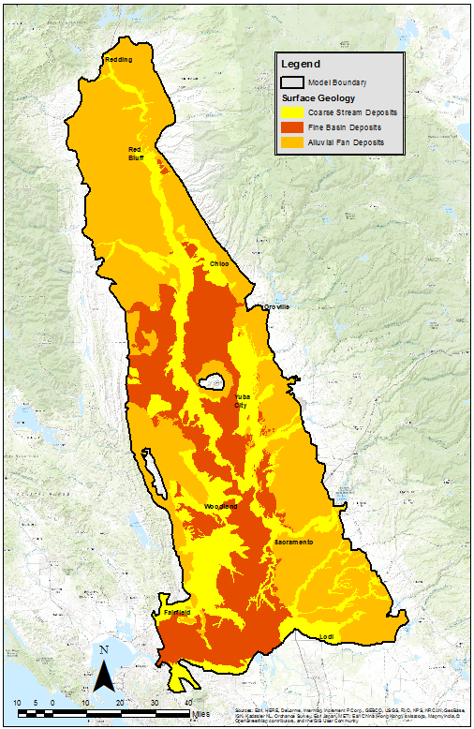

Figure – Map Showing the Geographic Extents of River, Basin, and Alluvial-Fan Deposits of the Surficial Deposits Within the Sacramento Valley. Sources: Helley and Harwood (1985), Mulder (2015), Wagner et. al. (1981, 1982, and 1991), and National Resources Conservation Service (2016).

**Well Layer Percent Coarse**

In Texture2Par, the percent coarse is calculated at each well location for every model layer that contains a well. The top and bottom elevation of the model layer at each well location must be identified to determine what portion of the well log occurs within the layer. In MODFLOW this is simply the layer elevation at the model cell in which each well is located. In IWFM, layer elevations are specified at nodes (points) that together form elements and thus the layer elevations must be interpolated to each well location. Using the three or four nodes of the triangular or quadrilateral element in which each well is located, inverse-distance weighting is used to determine the layer elevation at each well:

where *N* is the number of element nodes (3 for triangular elements, and 4 for quadrilateral elements), *wi* is the weight of *i*th node, *elevi* is the elevation at the *i*th node, and *di* is the distance between the well and the *i*th node.

The fraction of coarse-grained materials at each well within each model layer can be calculated using a length-weighted average of the texture data that occurs within the layer:

where *Pc* is the percent coarse of the specified layer, *L* is the layer length in the z-direction (element thickness), *NI* is the total number of lithologic intervals in the layers, *pci* is the binary coarseness of the *i*th interval, and *li* is the length (thickness) of the *i*th interval. An example of this is calculation for a single well is shown in Figure 3.

**Node/Cell Center Percent Coarse**

**After percent coarse is calculated at each well location within each layer, it is interpolated to each model grid location (nodes or cell centers) by layer using ordinary kriging (for a short discussion on kriging, see** Hydraulic Properties for Coarse and Fine Materials and Use of Pilot Points**). The quantity of wells being used in this step will determine the Texture2Par’s run time, which can range from seconds to hours.**

**If HGUs are specified within a layer, Texture2Par will only interpolate texture data from wells within the HGU to the node or cell within this unit. The assumption, and indeed intent of using HGUs is to separate distinct sediment units so that their texture measurements are not mixed. This could be useful, for instance, when surficial soil group locations are well known, or when the boundaries of a large clay unit have been identified underground. Notably, the HGUs are not used when calculating aquifer parameters – that spatial variation is controlled by** Pilot Points **and their separately designated zones, as described in the next section. While some users may find the separation of these two types of spatial zones cumbersome, it also provides an additional level of flexibility and spatial variation.**

**If the number of wells within that HGU are less than the number specified for kriging in the input file (“Wells used in kriging”), a warning will be written to the screen with the layer, HGU, and number of wells. The program will continue, and the smaller quantity of wells will be used in kriging (with a minimum of one well). Nodes/cells are divided into HGUs in the** Hydrogeologic Unit Input File**.**

**If HGUs are not being used (Hydrogeologic Unit File set to NONE) then Texture2Par proceeds as if all well log data is in one zone, in other words, all well log data will be considered in the node/cell interpolation (subject to the *n* nearest well logs being used for kriging).**

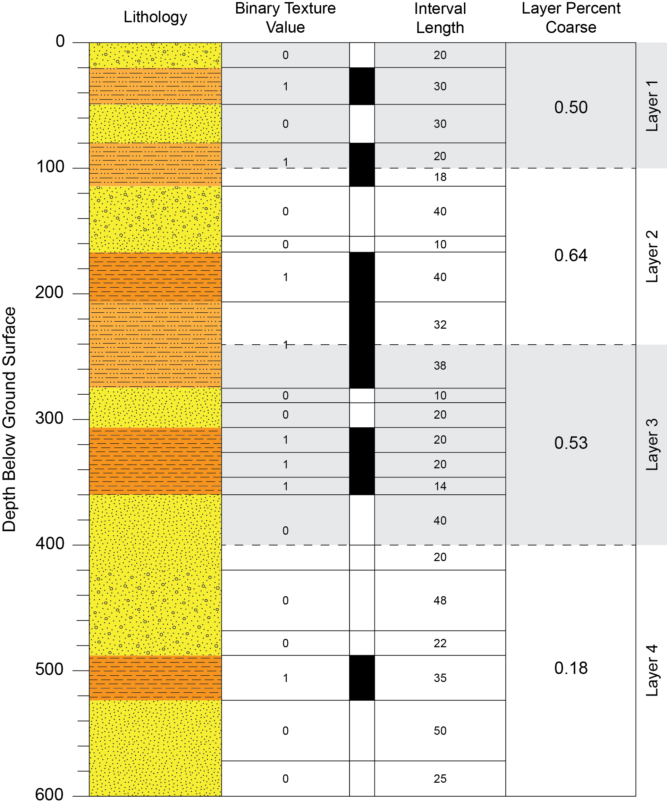

Figure 3 – Example of Lithological Log Intervals, Binary Texture Classifications for Each Interval (Coarse-Grained = 1, Fine-Grained=0), Division by Model Layer and Calculation of Percent Coarse Texture for Each Layer.

**Co-Located Well Handling**

**The kriging method, as an exact interpolator, does not work with co-located data. However, for various reasons (e.g., multilevel monitoring systems, estimated/rounded survey data), well location data may include multiple wells with identical x and y coordinate pairs. Ideally, these should be identified, checked, and handled prior to Texture2Par. Nonetheless, Texture2Par contains a simple co-location handling system. Co-located wells are moved 0.01 units in the positive x and y directions, with subsequent additional *n* co-located wells being moved an additional 0.01 * *n* units in x and y.**

**If co-located wells are found by Texture2Par, a warning is written to the console. After moving the wells apart, the maximum number of co-located wells at a single location and the maximum distance a well was moved are also written to the console.**

## Aquifer Parameter Calculations

The bulk aquifer parameters that are calculated by Texture2Par are the following:

* Horizonal hydraulic conductivity
* Vertical hydraulic conductivity
* Specific yield
* Specific storage

These values are characterized as “bulk” parameters because they represent an effective parameter value that has been upscaled to the model scale (Wen and Gómez-Hernández, 1996), taking into account regional heterogeneity, rather than the hydrogeologic properties at a specific point (Bond and Durbin, 2018). As required by the model input files that Texture2Par writes, these parameters are calculated at every node (IWFM) or every cell (MODFLOW).

A depth-dependent relationship is used to define the horizontal and vertical hydraulic conductivity of the coarse- and fine-grained materials. The depth-dependent relationship uses an exponential decay curve to represent the effects of compaction, cementation, and other physical processes that decrease hydraulic conductivity with increasing depth. This relationship takes a minimum hydraulic conductivity value (*HKmin*) and scales a maximum change value (*∆HKmax*) based on the depth *d* and the exponential decay constant *k*:

An example of the variation in conductivity with depth is shown in Figure 4. It should be mentioned that due to effects of upscaling, these “minimum” and “maximum” values do not (and should not) represent the actual minimum and maximum values of conductivity measured in the system. Instead, they should be understood as a range of average minimum and maximum values of a heterogenous material. The depth decay calculation is done for both for the coarse- and fine-grained horizontal hydraulic conductivities, both of which can have different decay constants *k*. The coarse- and fine-grained vertical hydraulic conductivities (*VK*) are calculated using the corresponding horizontal conductivities and the within-texture anisotropy value (*AnisoC* and *AnisoF*):

Separate anisotropy values can be used for course- and fine-grained materials. Importantly, when paired with the power law averaging, cells/nodes containing mixtures of coarse- and fine-grained sediments will potentially have a much higher effective anisotropy than specified in Texture2Par using the AnisoC and AnisoF parameters. As explained below, the empirical power law parameter will independently vary the horizontal and vertical conductivities, potentially further increasing the effective anisotropy of the resulting bulk values.

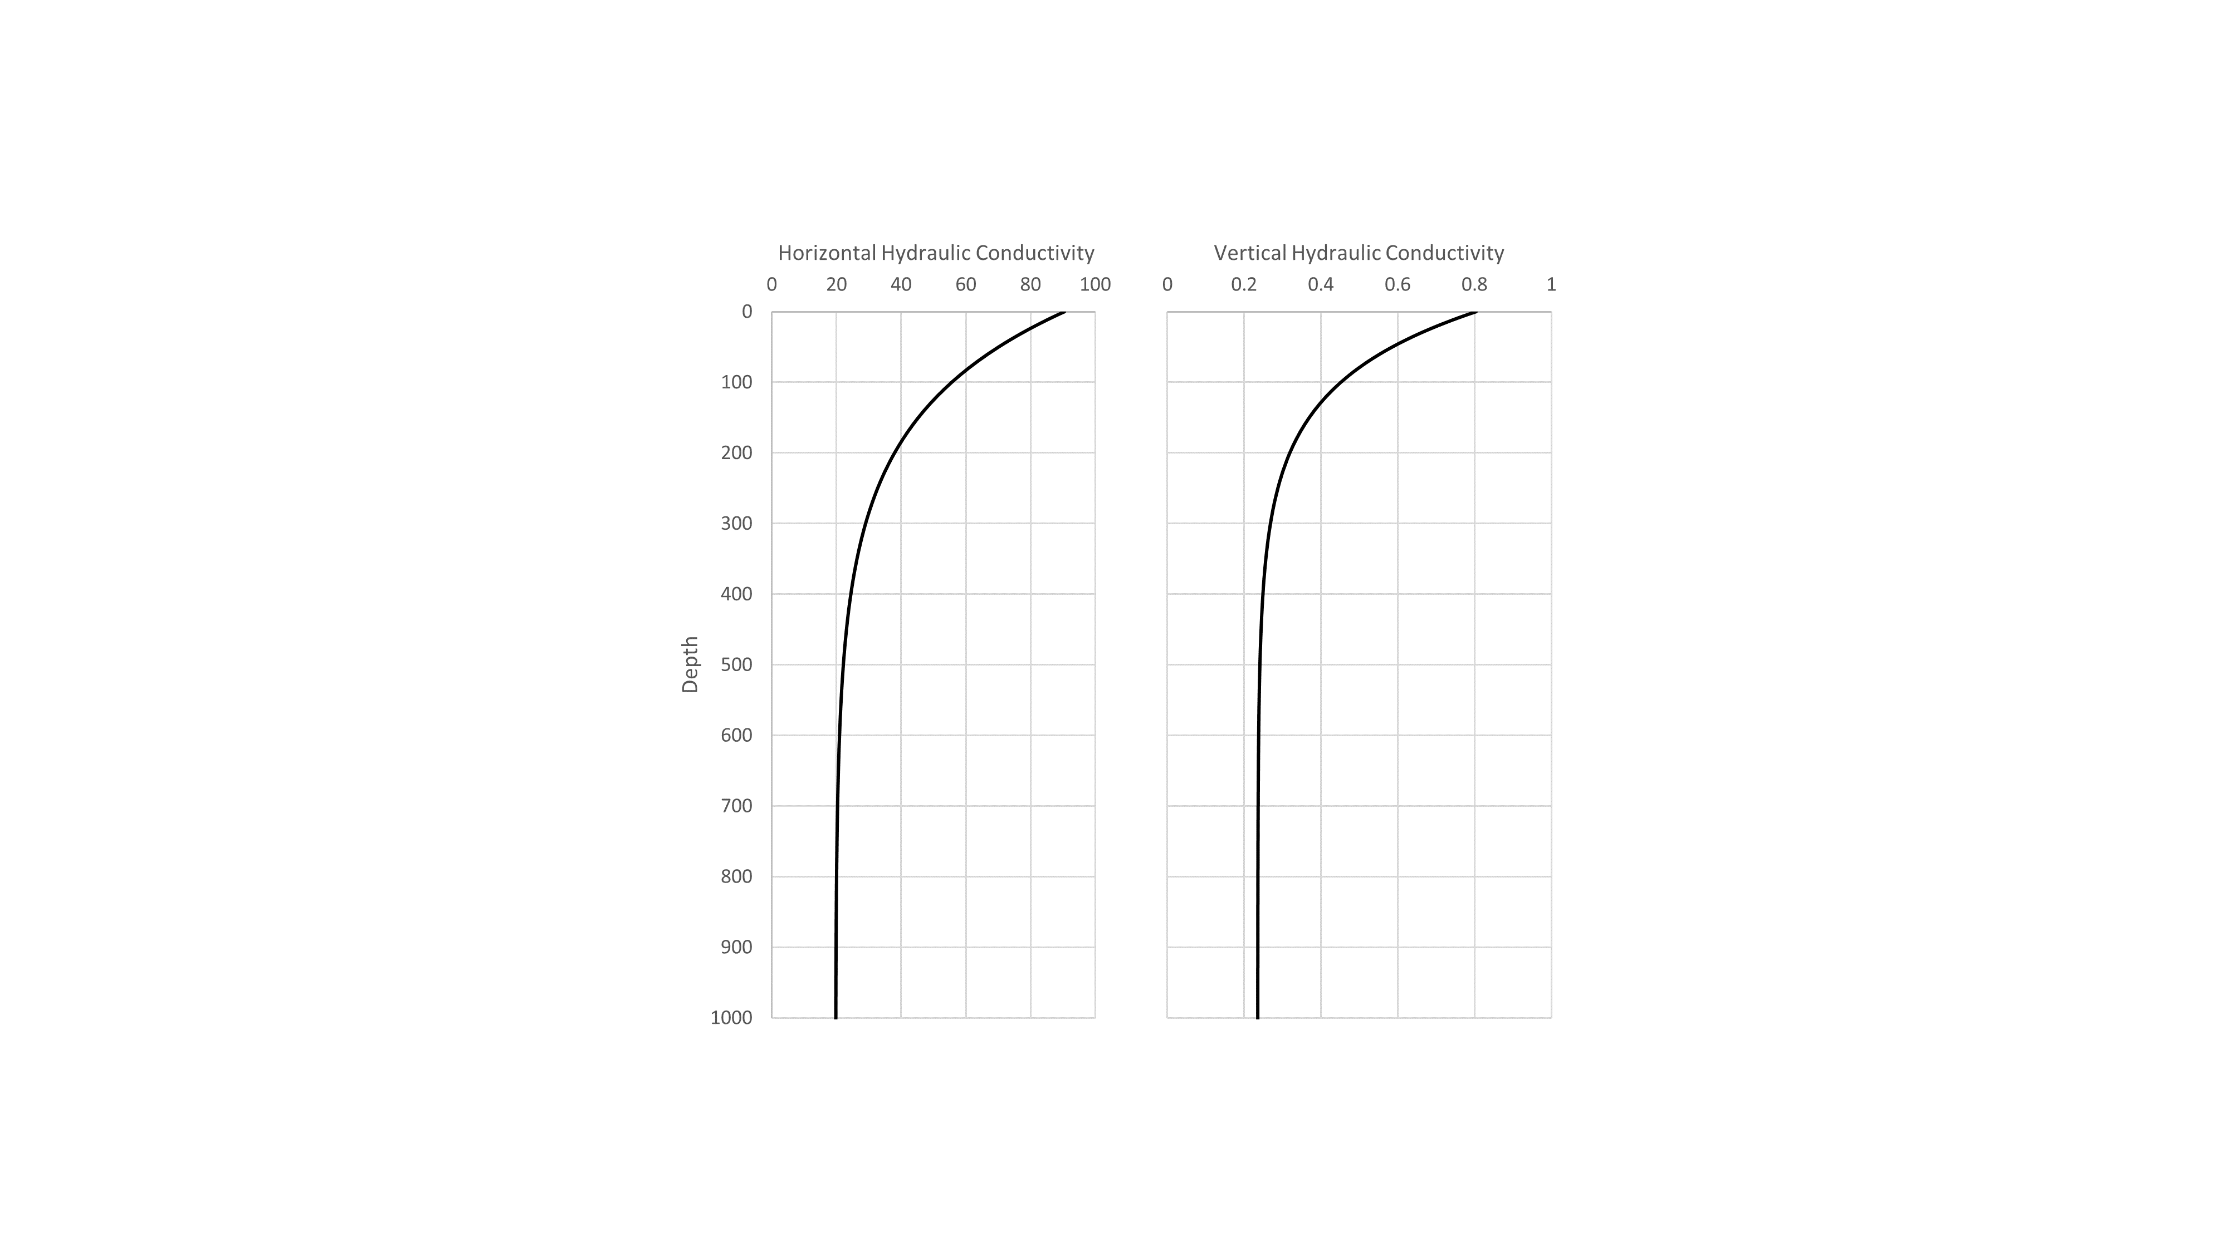

Figure 4 - Example Hydraulic Conductivity Depth Decay

The node/cell hydraulic conductivity and storage values are calculated using a power law averaging equation (Faunt, 2009):

where *X* is the bulk aquifer parameter, *Pc* is the proportion of coarse-grained material, (1-*Pc*) is the proportion of fine-grained material), *Xc* is the hydraulic-property value for the parameter with respect to the coarse-grained material, *Xf* is hydraulic-property value for the parameter with respect to the fine-grained material, and *p* values are coarse and fine empirical parameters related to flow path connectivity and the depositional structure of the groundwater system at the model scale.

The *p* parameters for hydraulic conductivity can range between -1 to 1, excluding zero (Bond and Durbin, 2018). This moves the average from an arithmetic average (at p =1) to a geometric mean (as p → 0) to a harmonic mean (p = -1). Generally, in an alluvial environment, the horizontal conductivity p value should be positive (0 – 1) and the vertical conductivity should be negative (-1 – 0) (Zanon et al., 2002; Cardwell and Parsons, 1945; Bond and Durbin, 2018). However, *p* should always be 1 for specific yield and specific storage because storage, averaged over a sufficiently large volume or area, is effectively independent of depositional structure, even though it remains related to the proportions of coarse-grained and fine-grained materials within the volume (Bond and Durbin, 2018). A grouped empirical parameter value is specified in the Main Input File for specific yield and specific storage. The *p* parameters are specified by the user for Texture2Par and this parameter is recommended to be developed external to the program in a data-driven analysis. While the value can be estimated using parameter optimization, given the resulting non-linearity of the problem it is best to determine the value prior to model calibration – particularly with large, complex models with long run times. Then, if necessary, that parameter value can serve as a starting point for optimization. More details on the development of the *p* parameter are available in Bond and Durbin (2018).

An example of the variation of all the aquifer parameters with percent coarse is shown in Figure 5. Horizontal and vertical hydraulic conductivity were calculated using values consistent with an alluvial environment found in Bond and Durbin (2018).

The initial values of these various input parameters (coarse- and fine- grained conductivity and storage values, depth decay parameters, and anisotropy values) can and should be estimated prior to running Texture2Par. Bond and Durbin (2018) explains a potential method and example for estimation. These estimates can then be refined using calibration and expanded spatially using pilot points with automated calibration.

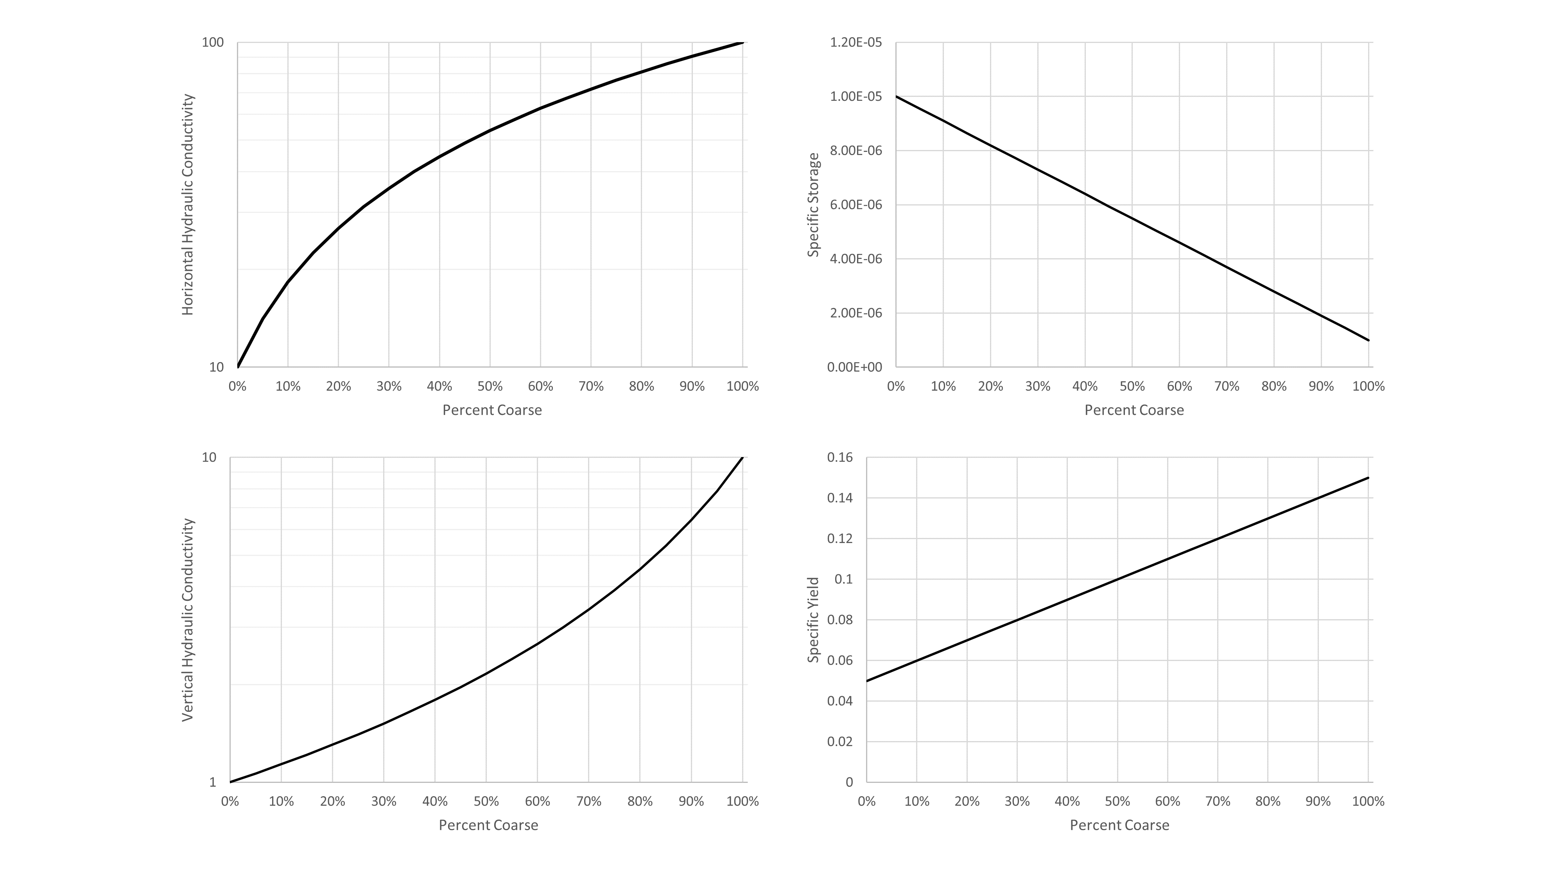

Figure - Example Aquifer Parameter Variation with Percent Coarse. Values for the power law averaging empirical *p* parameter are identical to those used in C2VSim. Note the hydraulic conductivity figures (left side) both have logarithmic y-axes.

## Hydraulic Properties for Coarse and Fine Materials and Use of Pilot Points

As described in the previous section, Texture2Par calculates hydraulic conductivity, specific storage, and specific yield using power law averaging between corresponding values for course-grained and fine-grained materials. At certain model scales, it may be necessary to incorporate spatial variations in these course- and fine- grained input parameters to account for regional variations and depositional patterns. To accommodate this, Texture2Par allows the user to assign these spatially varying properties to “pilot points” at user-defined locations within the model domain. Texture2Par uses kriging to then interpolate these values to nodes/cells over the model domain.

Kriging is a geostatistical technique for calculating the best linear unbiased estimate (BLUE) of a value at a given point using surrounding values (Deutsch and Journel, 1998). Ordinary kriging, the variant used in Texture2Par, assumes a non-stationary mean and thus requires no prior knowledge of the data distribution except for the variogram. The variogram establishes a relationship between the similarity (correlation) of pairs of points as a function of their distance.

By using pilot points, spatial variations can be smoothly introduced within the model without the need for an explicit assignment of values for every model node/cell by the user. This parsimony is of particular importance when using Texture2Par as a calibration utility, as it reduces the number of parameters which need to be estimated.

The hydraulic properties tied to pilot points that can vary spatially in Texture2Par via kriging are:

* Minimum horizontal hydraulic conductivity of coarse-grained materials (KCMin)
* Maximum change in coarse-grained horizontal hydraulic conductivity (DeltaKC)
* Minimum horizontal hydraulic conductivity of fine-grained materials (KFMin)
* Maximum change in fine-grained horizontal hydraulic conductivity (DeltaKF)
* Within-texture anisotropy of coarse-grained hydraulic conductivity (AnisoC)
* Within-texture anisotropy of fine-grained hydraulic conductivity (AnisoF)
* Specific storage for coarse-grained materials (SsC)
* Specific storage for fine-grained materials (SsF)
* Specific yield for coarse-grained materials (SyC)
* Specific yield for fine-grained materials (SyF)

Notably, the hydraulic conductivity depth decay parameters (*k* values) and power averaging parameters (*p* values) are not included in the pilot point parameter list. These are instead considered “global” variables and currently not allowed to vary spatially.

Additionally, pilot point hydraulic property interpolation can be constrained spatially by using pilot point zones. Interpolation of the hydraulic properties listed above is then restricted to node/cells within a matching pilot point zone (i.e., the node/cell is assigned the same integer zone value as the pilot point. If no zones exist (e.g., the cell/node pilot point zone input file is set to NONE) then Texture2Par treats all pilot points and node/cells as if they were in one single zone.

This specification of pilot point zones to nodes/cells should not be confused with the specification of HGUs in Texture2Par. The two have similarities – both are used to spatially limit what data are used in the interpolation to nodes/cells – but the two interpolation steps are entirely separate.

Within an HGU zone, ***texture* data from wells are interpolated to the node or cell within the zone as one of the initial steps in Texture2Par, while pilot point zones control the interpolation of within-texture *hydraulic properties* from pilot points to nodes/cells within the pilot point zones. Both the HGUs and the pilot points zones are optional**. Currently, in IWFM, pilot point zones are not able to vary with depth. Instead, the depth decay function is intended to provide all depth variation. However, when being used with MODFLOW, pilot point zones can vary by layer.

Zones do not need to be spatially continuous, but it is highly recommended that pilot points are generally centrally located within their target node/cell zone to aid in interpolation. A single pilot point within a zone results in a homogenous zone of hydraulic properties; however, the node/cell values will still vary due to the variance in the texture data.

Perhaps confusingly, a good basis for setting up pilot point zones would be to base them on your HGUs. When kriging aquifer parameter values over each model node/cell, only pilot points within the same zone number as the node/cell will be used in the interpolation. This can be used, for example, when your model contains geologically distinct areas with varying sediments.

A great resource for pilot point theory, primarily in the context of model calibration, is the USGS guide written by Doherty et al. (2010).

**Aquitard Parameters**

IWFM and MODFLOW both include the option to simulate aquitard units that are separate and distinct from aquifers. These aquitard units simulate resistance between layers, but do not simulate horizontal flow or changes in storage within the aquitard. In Texture2Par, aquitards can be represented by their own set of pilot points and all corresponding calculations to obtain bulk values are performed separately. For both IWFM and MODFLOW, the only aquitard parameters required by the model input files are vertical hydraulic conductivities. Because Texture2Par calculates the bulk vertical hydraulic conductivity based upon coarse- and fine-grained horizontal conductivity values and respective anisotropies, only those input parameters are required for aquitard pilot points. These parameters are KCMin, DeltaKC, KFMin, DeltaKF, AnisoC and AnisoF.

**Running Texture2Par Without Pilot Points**

Expressing the full spatial variability of the coarse-grained and fine-grained material hydraulic properties is not necessary or useful in all modeling situations. Therefore, in Texture2Par this simplification can be achieved by using a single pilot point – i.e., one line of values – and assigning all the nodes/cells to a single zone, which is the default when pilot points zones are not used. The heterogeneity that is represented solely by the interpolated values derived from the texture data will still provide for spatial variation in bulk aquifer parameters but will be based solely on the heterogeneity in the texture data and not through spatial (regional) variations in the coarse- and fine-grained material property values.

## ****Assumptions, Limitations, and Plans for Future Developments****

The empirical relationships described in this report for deriving bulk aquifer parameter values from texture data are most suitable for application within HGUs that do not internally exhibit very large variations in the sediment source materials, sediment structure, cementation, or constituents of the fine fraction (i.e., silts versus clays, for reasons that are expanded upon below). The employed empirical relationships are very effective at translating variations in texture proportions within a formation into plausible expressions of hydraulic heterogeneity throughout that HGU. Texture2Par, in its current version, does not directly or automatically identify or delineate HGUs for this purpose. This work must be completed by the user, and can be accomplished for example via:

* Geologic / stratigraphic mapping,
* Geophysical studies, such as airborne, surface, or downhole surveys, and/or,
* A combination of the above.

If geological and/or geophysical analyses suggest that the subsurface does not exhibit great contrasts that warrant the definition of texturally distinct HGUs, then Version 1 of Texture2Par can be used to fully parameterize the 3D groundwater model in a single execution using model-wide values for the properties of the coarse and fine fractions. However, if the subsurface is subdivided into texturally distinct HGUs following geological and/or geophysical analyses then Version 1 of Texture2Par may be executed in the following manner to fully parameterize the 3D groundwater model:

1. The HGU information can be used to separate texture data in the Well Log Input File and Hydrogeologic Unit Input File, and/or used to delineate pilot point zones specified in the Main Input File and the MODFLOW pilot point zones file. Using the pilot point technique to represent values for the properties of the coarse and fine fractions, and the exponents appearing in the empirical relationships, that are specific to each HGU, requires that Texture2Par only be executed once. This approach relies upon the pilot point capabilities of Texture2Par to distinguish the HGUs.
2. Texture2Par currently does not allow the power law exponents to vary spatially or with depth. This limits the applicability of Texture2Par when used, for example, in a region where the depositional environment varies heavily, changing the geometric orientations and/or patterns of the various sediment distributions. Future versions may allow these exponents to be included in the pilot point parameters, thus allowing spatial variation. For now, variations in the non-pilot point parameters – including the depth-decay parameter, variogram model, and power law exponents requires executing multiple Texture2Par runs and using an external utility to combine the various outputs.

Care must be taken when combining texture information from different data sources, agencies, or practitioners, or derived using different techniques. Unknown textural variation can be introduced when:

* The methods used to obtain and estimate texture proportions may have differed between the various data sources.
* Quality assurance and control procedures may have differed between the various data sources.
* Information regarding the components and treatment of both the very-coarse and the very-fine fractions of the sediment is often lacking. For example, some practitioners remove the very coarse (e.g., > 2mm) fraction before calculating proportions, whereas others do not.

A fine fraction dominated by clay materials can reflect a very different depositional environment, and very different hydraulic properties, than a fine fraction dominated by silts. Currently, Texture2Par does not differentiate between silts and clays in the non-coarse percentage of texture (i.e., 1- *Pc*). The character of the fine fraction can be vitally important: fine clays deposited in a lake or marine environment likely produce very different aquifer properties (particularly vertical hydraulic conductivity and anisotropy) than fine sands or silts deposited in a fluvial environment. Expanding the capabilities of Texture2Par to consider not only a binary classification but to accommodate a greater number of sediment fractions could explicitly handle the clay fraction. This work is presently under way.

Finally, Version 1 of Texture2Par does not account for decline in storage values with increasing depth. Although evidence for this characteristic is weaker than for the decline in hydraulic conductivity, this characteristic may be of importance to some studies – such as subsidence analysis – and as such, this feature is planned to be added in a future release of the software.

Limitations related to IWFM and MODFLOW configurations are discussed in the IWFM-Specific Input Instructions and MODFLOW-Specific Input Instructions sections, respectively.

# Input Instructions for Texture2Par

Texture2Par has two text (ASCII) input files specific to the program that are required: the main input file (Texture2Par.in) and a well log texture file. In addition, it uses the target model’s own input files to determine the model discretization and certain relevant settings. This chapter first details the two Texture2Par-specific files, then dives into the model-specific files that are read and written, and the limitations of the utility to handle certain model settings and setups.

## Main Input File

The main input file is named Texture2Par.in and must be in the same directory that the application is run. It consists of seven sections:

1. Main Input Settings
2. Model Specific Settings
3. Program Output Settings
4. Variogram Settings
5. Global Settings
6. Aquifer Pilot Points
7. Aquitard Pilot Points

Each of these sections must be designated by one or more header lines starting with an asterisk (*). The program assumes the sections are in the order listed above and has no ability to recognize if a section is missing or has missing lines of data. Texture2Par will crash with an error if the file ends unexpectedly.

Except for the pilot point values, all settings are entered on their own line, with the value followed by a forward slash (/) and a short, descriptive parameter name. File paths should only contain back slashes (\) between directories and cannot contain spaces. Two periods followed by a back slash (..\) can be used to denote the directory “above” the directory Texture2Par is being run in (i.e. the parent directory).

Example Texture2Par Main Input Files are shown for IWFM and MODFLOW in Figure 6 and Figure 7, respectively. Settings specific to each model are shown in blue, and section headers (commented lines) are shown in green.

*==============================================================================

* Texture2Par Main Input File

*==============================================================================

IWFM / Model Type

welllog.dat / Well Log File

geounits.dat / Hydrogeologic Units File

*------------------------------------------------------------------------------

* Model Settings (IWFM)

*------------------------------------------------------------------------------

Model.in / Simulation File

..\Preproc\Preprocessor.in / Pre-processor File

Groundwater_template.dat / GW Template File

nodezones.dat / Pilot Point Node Zones File

*------------------------------------------------------------------------------

* Program Settings (True/False)

*------------------------------------------------------------------------------

False / Output Node Files

*------------------------------------------------------------------------------

* Variogram Settings

* itype: 0-linear variogram, 1-spherical variogram, 2-exponential variogram

*------------------------------------------------------------------------------

1 / Variogram Type (itype)

1.0 / Sill

1.0E7 / Range

1.0E7 / Minimum Range

0.0 / Anisotropy Angle (from North)

0.0 / Nugget

16 / Wells used in kriging

*------------------------------------------------------------------------------

* Global Settings

*------------------------------------------------------------------------------

0.007 / KCk

0.0099 / KFk

0.93 / KHp

-0.62 / KVp

1.0 / Syp

*------------------------------------------------------------------------------

* Pilot Points - X Y KCMin deltaKC KFMin deltaKF SsC SsF SyC SyF AnisoC AnisoF Zone

*------------------------------------------------------------------------------

1935427.0 14328901.0 43.80 159.0 .990 2.31 5.192D-7 .0022 .105 .07 10 10 1

1942143.0 14232656.0 43.80 159.0 .990 2.31 5.192D-7 .0022 .105 .07 10 10 1

1995000.0 14148550.0 43.80 159.0 .990 2.31 5.192D-7 .0022 .105 .07 10 10 2

2042996.0 14022793.0 43.80 159.0 .990 2.31 5.192D-7 .0022 .105 .07 10 10 2

*------------------------------------------------------------------------------

* Aquitard Pilot Points - X Y KCMin deltaKC KFMin deltaKF AnisoC AnisoF Zone

*------------------------------------------------------------------------------

2195040.8 13653266.2 .0087 .024 .06893 .03459 10.0 10.0 1

2400067.6 13529296.5 .0087 .024 .06893 .03459 10.0 10.0 2

*------------------------------------------------------------------------------

* EOF

*------------------------------------------------------------------------------

Figure - Example Texture2Par Main Input File for IWFM Models

*==============================================================================

* Texture2Par Input File

*==============================================================================

MODFLOW / Model Type

welllog.dat / Well Log File

geounits.dat / Hydrogeologic Units File

*------------------------------------------------------------------------------

* Model Settings (MODFLOW)

*------------------------------------------------------------------------------

MFModel.nam / Name File

MFModel_template.lpf / Layer Parameter Template File

ppzones.dat / Pilot Point Zones File

0.0 / xOffset

0.0 / yOffset

0.0 / Rotation

*------------------------------------------------------------------------------

* Program Settings (True/False)

*------------------------------------------------------------------------------

False / Output Cell Files

*------------------------------------------------------------------------------

* Variogram Settings

* itype: 0-linear variogram, 1-spherical variogram, 2-exponential variogram

*------------------------------------------------------------------------------

1 / Variogram Type (itype)

1.0 / Sill

1.0E7 / Range

1.0E7 / Minimum Range

0.0 / Anisotropy Angle (from North)

0.0 / Nugget

16 / Wells used in kriging

*------------------------------------------------------------------------------

* Global Settings

*------------------------------------------------------------------------------

0.007 / KCk

0.0099 / KFk

0.93 / KHp

-0.62 / KVp

1.0 / Syp

*------------------------------------------------------------------------------

* Pilot Points - X Y KCMin deltaKC KFMin deltaKF SsC SsF SyC SyF AnisoC AnisoF Zone

*------------------------------------------------------------------------------

1935427.0 14328901.0 43.80 159.0 .990 2.31 5.192D-7 .0022 .105 .07 10 10 1

1942143.0 14232656.0 43.80 159.0 .990 2.31 5.192D-7 .0022 .105 .07 10 10 1

1995000.0 14148550.0 43.80 159.0 .990 2.31 5.192D-7 .0022 .105 .07 10 10 2

2042996.0 14022793.0 43.80 159.0 .990 2.31 5.192D-7 .0022 .105 .07 10 10 2

*------------------------------------------------------------------------------

* Aquitard Pilot Points - X Y KCMin deltaKC KFMin deltaKF AnisoC AnisoF Zone

*------------------------------------------------------------------------------

2195040.8 13653266.2 .0087 .024 .06893 .03459 10.0 10.0 1

2400067.6 13529296.5 .0087 .024 .06893 .03459 10.0 10.0 2

*------------------------------------------------------------------------------

* EOF

Figure - Example Texture2Par Main Input File for MODFLOW Models

**Main Input Settings**

**Model Type** – *Text String*

Either “IWFM” or “MODFLOW” depending on the type of flow model being used with the utility.

**Well Log File** – *File Path String*

File name of the well log data file (see the Well Log File section).

**Hydrogeologic Unit File** – *File Path String or NONE*

File name of the node/cell hydrogeologic unit file (see the Hydrogeologic Unit Input File section). To not include hydrogeologic units, the string NONE can be input instead.

**Model Settings – If Model Type is IWFM**

**Simulation File** – *File Path String*

File name of the IWFM main simulation file.

**Pre-processor File** – *File Path String*

File name of the IWFM pre-processor simulation file. Texture2Par may have trouble if relative paths are used in the pre-processor simulation file.

**Groundwater Template File** – *File Path String*

File name of the IWFM groundwater file to be used as a template when writing the output groundwater file. The settings (e.g., input out data file names, hydrograph outputs, initial heads) in this template file will all be copied over to the output groundwater file.

**Pilot Point Node Zones File** – *File Path String or NONE*

File name of the pilot point node zone input file (see IWFM Pilot Point Zone Input File). To skip using pilot point zones, the string NONE can be input instead.

**Model Settings – If Model Type is MODFLOW**

**Name File** – *File Path String*

File name of the MODFLOW name file that lists the packages used by the model. If necessary, this can be a copied name file specifically for Texture2Par. The name file should be in the same folder where Texture2Par is being run.

**Layer Parameter Template File** – *File Path String*

File name of the MODFLOW LPF or UPW (MODFLOW-NWT) to be used as a template when writing the output groundwater file. This file is read by Texture2Par rather than the one listed in the Name file to obtain flags, options, and arrays not calculated or relevant to Texture2Par.

**Pilot Point Zone File** – *Text String or NONE*

File name of the pilot point zone input file (see MODFLOW Pilot Point Zone Input File). To skip using pilot point zones, the string NONE can be input instead.

**xOffset** – *Real Number*

Real-world x-coordinate of the lower-left corner of the model grid. This is used to convert the model grid into real-world coordinates to determine which model cell each well is located inside.

**yOffset** – *Real Number*

Real-world y-coordinate of the lower-left corner of the model grid. This is used to convert the model grid into real-world coordinates to determine which model cell each well is located inside.

**Rotation** – *Real Number*

Counter-clockwise rotation of the model grid, relative to the real-world coordinate system. This is used to convert the model grid into real-world coordinates to determine which model cell each well is located inside.

**Program Settings**

**Output (Cell/Node) Files** – *Boolean (True/False)*

If set to True, writes files of all coarse- and fine-grained hydraulic parameters and percent coarse values at each layer of every node/cell, as well as the percent coarse calculated for each layer section of every well. This can be useful for checking these intermediate results or for using them in other calculations. False prevents writing of these files, possibly offering slight improvements to Texture2Par run times (useful during parameter estimation, where Texture2Par may run very many times).

**Variogram Settings**

The variogram implementation within Texture2Par is a slightly modified version of the GSLIB variogram model and uses many of the same parameters, although simplified for two dimensions. For more information on these parameters and their use, consult the GSLIB manual (Deutsch and Journel, 1998).

**Variogram Type** – *Integer*

0 – Linear

1 – Spherical

2 – Exponential

**Sill** – *Real Number*

Variogram model sill, the maximum value of the semi-variance which occurs at the variogram range.

**Maximum Range** – *Real Number*

Variogram model range in the direction of maximum continuity (the direction specified by Anisotropy Angle), the distance at which the variogram model flattens out to the value specified for the sill.

**Minimum Range** – *Real Number*

Variogram model range in the direction perpendicular to the direction of maximum continuity. If the variogram model does not exhibit anisotropy, this value should be set to the same value as the maximum range.

**Anisotropy Angle** – *Real Number*

Angle of rotation on the y-axis of the variogram model, clockwise from north. The y-axis should be rotated such that it extends in the direction of maximum continuity.

**Nugget** – *Real Number*

Variogram model nugget, the semi-variance at zero separation distance.

**Wells Used in Kriging** – *Integer*

Number of closest wells to use in kriging percent coarse to nodes/cell centers. This value can have a drastic impact on the runtime of Texture2Par. It is likely not feasible, or necessary, to set this number to the number of wells in the well log file. The user should experiment with different values to determine a value which fits their model needs.

**Global Settings**

**KCk** – *Real Number*

Coarse-grained material hydraulic conductivity depth decay constant.

**KFk** – *Real Number*

Fine-grained material hydraulic conductivity depth decay constant.

**KHp** – *Real Number (between -1 and 1)*

Horizontal hydraulic conductivity empirical power law averaging parameter.

**KVp** – *Real Number (between -1 and 1)*

Vertical hydraulic conductivity empirical power law averaging parameter.

**Syp** – *Real Number (between -1 and 1)*

Specific yield empirical power law averaging parameter.

**Hydraulic Properties Parameters and Pilot Point Settings**

This section follows a different format than that of those above it. Each line represents a single pilot point and contains a number of values associated with that point. The items below all must be present for each pilot point line. All values are real numbers except the pilot point zone, which is an integer. There must be at least one pilot point present per zone.

**X** – Real-world x-coordinate of the pilot point

**Y** – Real-world y-coordinate of the pilot point

**KCMin** – Minimum coarse-grained hydraulic conductivity

**DeltaKC** – Maximum coarse-grained hydraulic conductivity value to be added to the minimum

**KFMin** – Minimum fine-grained hydraulic conductivity

**DeltaKF** – Maximum coarse-grained hydraulic conductivity value to be added to the minimum

**SsC** – Coarse-grained specific storage parameter

**SsF** – Fine-grained specific storage parameter

**SyC** – Coarse-grained specific yield parameter

**SyF** – Fine-grained specific yield parameter

**AnisoC** – Within-texture anisotropy of hydraulic conductivity of coarse-grained materials

**AnisoF** – Within-texture anisotropy of hydraulic conductivity of fine-grained materials

**Zone** – Node/cell zone that the pilot point should be associated with for kriging the hydraulic properties of the coarse- and fine-grained materials from pilot points to nodes/cells (a dummy value should still be entered if zones are not being used)

**Aquitard Pilot Points**

This section is identical to the Aquifer Pilot Point section of the main input file, although only vertical hydraulic conductivity is calculated for aquitards, so only a subset of parameters is required. If no aquitards are present in the model this section can be left empty. For more information about aquitard representation in MODFLOW, see Aquitard Support – Quasi-3D Confining Beds.

**X** – Real-world x-coordinate of the pilot point

**Y** – Real-world y-coordinate of the pilot point

**KCMin** – Minimum coarse-grained hydraulic conductivity

**DeltaKC** – Maximum coarse-grained hydraulic conductivity value to be added to the minimum

**KFMin** – Minimum fine-grained hydraulic conductivity

**DeltaKF** – Maximum coarse-grained hydraulic conductivity value to be added to the minimum

**AnisoC** – Within-texture anisotropy of hydraulic conductivity of coarse-grained materials

**AnisoF** – Within-texture anisotropy of hydraulic conductivity of fine-grained materials

**Zone** – Node/cell zone that the pilot point should be associated with for kriging the hydraulic properties of the coarse- and fine-grained materials from pilot points to nodes/cells (a dummy value should still be entered if zones are not being used)

**End-of-File**

Included in the Texture2Par example main input files is an end-of-file (EOF) section to mark the end of the file. This is not required or used in any way by Texture2Par but can be useful in denoting the end of the pilot point section.

## Well Log Input File

The well log input file contains all the texture data used by Texture2Par in its calculations. It consists of a header line with a label for each data column in the file, followed by an unlimited number of lines. Each line represents one discrete depth interval of a well with a corresponding binary (1 or 0) texture (percent coarse) value. The intervals are defined in the file by their bottom depth, with the interval top being the bottom of the preceding interval (or, in the case of the first interval, the ground surface). Below is a description of the columns, in order, that must be included on each line, separated by one or more spaces. Figure 8 shows several lines from an example Well Log Input File.

Name WellNo Interval PC X Y Zland Depth Layer1 Layer2 Layer3

Bwell_001 1 1 1 1162.6115 4839.6188 115.0 12.5 Coarse1 Coarse1 Fine1

Bwell_001 1 2 1 1162.6115 4839.6188 115.0 25.0 Coarse1 Coarse1 Fine1

Bwell_001 1 3 1 1162.6115 4839.6188 115.0 40.0 Coarse1 Coarse1 Fine1

Bwell_001 1 4 1 1162.6115 4839.6188 115.0 117.0 Coarse1 Coarse1 Fine1

Bwell_002 2 1 0 1912.0032 4861.9221 110.0 13.5 Fine1 Fine1 Fine2

Bwell_002 2 2 1 1912.0032 4861.9221 110.0 22.0 Fine1 Fine1 Fine2

Bwell_002 2 3 1 1912.0032 4861.9221 110.0 43.0 Fine1 Fine1 Fine2

Bwell_002 2 4 0 1912.0032 4861.9221 110.0 100.0 Fine1 Fine1 Fine2

Bwell_003 3 1 1 1099.3512 4893.1468 115.0 10.2 Fine1 Coarse2 NoUnit

Bwell_003 3 2 1 1099.3512 4893.1468 115.0 13.4 Fine1 Coarse2 NoUnit

Bwell_003 3 3 1 1099.3512 4893.1468 115.0 24.2 Fine1 Coarse2 NoUnit

Bwell_003 3 4 1 1099.3512 4893.1468 115.0 30.0 Coarse2 Coarse2 NoUnit

Bwell_003 3 5 0 1099.3512 4893.1468 115.0 50.0 Coarse2 Coarse2 NoUnit

Bwell_003 3 6 0 1099.3512 4893.1468 115.0 150.0 Coarse2 Coarse2 NoUnit

Bwell_003 3 7 1 1099.3512 4893.1468 115.0 200.0 Coarse2 Coarse2 NoUnit

Bwell_003 3 8 0 1099.3512 4893.1468 115.0 225.0 Coarse2 Coarse2 NoUnit

Figure - Excerpt from an Example Well Log Input File with the Hydrogeological Units Specified for Three Layers (Last Three Columns)

**Name** – Text string, with no spaces, representing the name of the well. This input is expected but is not used internally by Texture2Par and exists for tracking purposes only.

**Well Number** – Integer used to group intervals by wells. The well numbers should count from 1 to the total number of wells, with no values skipped.

**Interval** – Integer used to order intervals within wells. Ideally, the intervals are listed in ascending order within each well. The interval number should count the number of discrete well depth intervals starting from the shallowest interval (1) to the deepest interval, with no values skipped.

**Percent Coarse (PC)** – 0 or 1 representing a fine or coarse interval of texture, respectively. A negative integer (e.g., -999) indicates a “no data” interval which will be excluded from calculations.

**X** – Real-world x-coordinate of the well

**Y** – Real-world y-coordinate of the well

**Zland** – Ground surface elevation at the well

**Depth** – Distance from the well ground surface to the **bottom** of the texture interval.

**Hydrogeologic Unit** (if a hydrogeologic unit node/cell file was provided) – a character string of the hydrogeologic unit name must be included for each layer (see Figure 8 for a three-layer example). If hydrogeologic units are not being used (filename set to “NONE” in the Texture2Par main input file) then these columns are **not** required and not read.

## Hydrogeologic Unit Input File

When HGUs are being used to augment the percent coarse information in the well log file, a simple input file is required to assign the model nodes/cells to each hydrogeologic unit. Figure 9 displays the layout of these files for both IWFM and MODFLOW models. For both simulation codes, each line consists of an identifier for the grid (node or cell row/column) followed by a character string with the name of the hydrogeologic unit for each layer present (in the example, there are three layers). Values can be separated by one or more spaces or tabs. In the example, “NoUnit” is being used as a catch-all HGU for locations where no known HGU exists.

Row Col 1 2 3

1 1 Coarse1 Coarse Fine1

1 2 Coarse1 Coarse Fine1

1 3 Coarse1 Coarse Fine1

1 4 Coarse1 Coarse Fine1

1 5 Coarse1 Coarse Fine1

1 6 Coarse1 Coarse Fine1

1 7 Coarse2 Fine2 NoUnit

1 8 Coarse2 Fine2 NoUnit

1 9 Coarse2 Fine2 NoUnit

1 10 Coarse2 Fine2 NoUnit

Node 1 2 3

1 Coarse1 Coarse Fine1

2 Coarse1 Coarse Fine1

3 Coarse1 Coarse Fine1

4 Coarse1 Coarse Fine1

5 Coarse1 Coarse Fine1

6 Coarse1 Coarse Fine1

7 Coarse2 Fine2 NoUnit

8 Coarse2 Fine2 NoUnit

9 Coarse2 Fine2 NoUnit

10 Coarse2 Fine2 NoUnit

Figure - Excerpt from Example Hydrogeologic Unit Input Files for MODFLOW (left) and IWFM (right).

HGUs are used to separate out texture data into different sediment groups or classes. This is further explained in the Texture Interpolation methodology section.

## IWFM-Specific Input Instructions

### IWFM Input Files

Texture2Par reads four of IWFM input files to determine model discretization:

1. Pre-Processing File
2. Node X-Y Coordinate File
3. Element Configuration File
4. Stratigraphic Data File

It additionally reads the IWFM Main Input File to determine the name/location of the Groundwater Component Main File. The Groundwater file is not read, instead the name is used to determine the name of the file output by Texture2Par. This means **Texture2Par will overwrite the original IWFM Groundwater file**.

Additionally, as discussed in the Texture2Par Main Input File section, a temporary IWFM Groundwater file is required so that Texture2Par can maintain the non-aquifer parameter settings and values (e.g., initial heads). One possible workflow is to rename the existing Groundwater file, appending the existing name with “_template” and to use that file as the Groundwater Template File required by the Texture2Par Main Input File. This way should there be something wrong with the Groundwater file written by Texture2Par there will always be a backup of the original in the form of the template file.

Texture2Par assumes the user is using a consistent set of spatial and temporal units, however, it does use the conversion factors specified within the Node X-Y Coordinate and Stratigraphic Data files and assumes that these factors convert the node coordinates, elevations, and layer thicknesses to a unit and/or projection consistent with the data in the Well Log Input File.

### IWFM Pilot Point Zone Input File

If no pilot point zone file is present in the input file (i.e., “NONE”) then pilot point zones are not used. To specify pilot point zones Texture2Par requires a specialized zone input file to designate what zone each node belongs to. This file consists of a header line with labels for each of the two columns, followed by a line for each model node. Each of these lines should contain the following two integers, separated by one or more spaces or tabs:

1. Node Number
2. Pilot Point Zone Number

Ideally, this file is sorted by ascending node number although this is not required. Pilot point zones are expanded upon in the Hydraulic Properties for Coarse and Fine Materials and Use of Pilot Points methods section.

### IWFM Output

Texture2Par’s primary output for IWFM flow models is a new Groundwater Component Main File. As mentioned above, **Texture2Par will overwrite the original IWFM Groundwater file**.

In IWFM, there are two ways aquifer parameters that can be specified in the Groundwater file:

1. By use of a parametric grid (NGROUP > 0)
2. At every groundwater node (NGROUP = 0)

**Texture2Par currently only supports Option 2: At every groundwater node**.

Optionally, Texture2Par will also output a variety of calculated parameters to text files for other calculations and debugging. This is activated by setting Output Node Files in the Texture2Par Main Input File to “True”. Table 1 lists the files written when this option is invoked.

Table 1 - Optional Output Files for IWFM Flow Models

|  |  |
| --- | --- |
| **File Name** | **Description** |
| t2p_WellPC.out | Percent coarse at wells |
| t2p_WellAqTardPC.out | Aquitard percent coarse at wells |
| t2p_NodePC.out | Percent coarse at nodes |
| t2p_NodeAqTardPC.out | Aquitard percent coarse at nodes |
| t2p_KhB.out | Horizontal hydraulic conductivity at nodes |
| t2p_KvB.out | Vertical hydraulic conductivity at nodes |
| t2p_SsB.out | Specific storage at nodes |
| t2p_SyB.out | Specific yield at nodes |
| t2p_InterbedThickness.out | Estimated interbed thickness (percent fine * layer thickness) |
| t2p_AqTardKvB.out | Aquitard vertical hydraulic conductivity at nodes |

In each file, every line represents a single node or well. Values are included for every model layer and presented in columns. Headers are included in the text files. For the node output files, the calculated real-world coordinates are also written.

### IWFM Limitations

This section details the known limitations of Texture2Par in its compatibility with IWFM models.

* Texture2Par has only been tested with IWFM 2015.
* Parametric grid is not supported as output in the Groundwater file (NGROUP must be set to 0).
* Only spatially distributed two-dimensional (2D) pilot point zones exist, therefore, a pilot point zone assigned to a node is assumed for all layers.

## MODFLOW-Specific Input Instructions

### MODFLOW Input Files

Texture2Par reads the MODFLOW name file to determine model type and find the accompanying packages. Texture2Par will open these files and read them to determine the model discretization. Specifically, it requires these packages to be in the name file:

1. Discretization (DIS)
2. Basic (BAS6)
3. Layer-Property Flow (LPF) or Upstream Weighting (UPW)

Unrecognized packages in the name file will be ignored, but still printed to a Texture2Par-specific list file (t2p_modflow.lst). This file can be very useful in diagnosing any issues Texture2Par has in reading the model files. If necessary, the user can create a duplicate name file for Texture2Par with any non-necessary packages commented out (using the symbol “#” used by MODFLOW) or removed.

The LPF or UPW file provided in the name file is not actually read by Texture2Par. The file name and the unit number are instead used to write the new LPF/UPW file. This means **Texture2Par will overwrite the original MODFLOW LPF or UPW package file**.

Additionally, as discussed in the Texture2Par Main Input File section, a temporary LPF or UPW file is required so that the program can maintain the settings, options, and data sets in those packages not written by Texture2Par. One possible workflow is to rename the existing LPF/UPW file, appending the existing name with “_template” and to use that file as the Layer Parameter Template File required by the Texture2Par Main Input File. This way should there be something wrong with the LPF/UPW file written by Texture2Par, the user will always have a backup of the original in the form of the template file.

### MODFLOW Pilot Point Zone Input File

If no pilot point zone file is present in the input file (i.e., “NONE”) then pilot point zones are not used. For MODFLOW, pilot point zones are allowed to vary both horizontally and vertically (by layer). The input is given as 2D arrays, from top layer to bottom layer, similar to many MODFLOW input files. Zones are assigned as integers by cell in the array, the values correspond to zone values assigned to pilot points in the Main Input File.

An example of a model with three layers is given in Figure 10. No text is required before the arrays, however, using comments (#) to separate the various layers is recommended. Similarly, it is convenient to have the columns and rows of the 2D array correspond to the correct number of rows and columns in the MODFLOW model, but it is not required, as long as the order of values is the same. In the example, the model has 10 columns and *n* rows, with a row of dots (. . .) signifying the jump to the *n*th row.

The third layer has a value below zero (-1), which tells Texture2Par to reuse the previous zone array (in this case, Layer 2).

# Layer 1

1 1 1 1 1 1 1 2 2 1

1 1 1 1 1 1 2 2 2 2

. . .

2 2 2 1 1 1 2 2 2 2

# Layer 2

1 1 1 1 1 1 1 2 2 1

1 1 1 1 1 1 2 2 2 2

. . .

2 2 2 1 1 1 2 2 2 2

# Layer 3

-1

Figure - Example MODFLOW Pilot Point Zones Input File

Pilot point zones are expanded upon in the Hydraulic Properties for Coarse and Fine Materials and Use of Pilot Points methods section.

### Aquitard Support – Quasi-3D Confining Beds

There are a few possible ways to represent an aquitard within MODFLOW, but as of now the only one recognized by Texture2Par is through the use of Quasi-3D confining beds. In this method, aquitards are not included as an explicit model layer but are instead modeled as a vertical leakance between layers.

In MODFLOW, Quasi-3D confining beds are setup in the discretization (DIS) file. The LAYCBD flags for each layer indicate whether that layer has a Quasi-3D confining bed below it (any non-zero integer indicates it exists). MODFLOW will then look for an extra bottom elevation (BOTM) array after the aquifer BOTM array for the layer. This will also serve as the top for the layer below. The deepest layer of the model cannot have a confining bed. For more information, see the MODFLOW-2005 Input Instructions (USGS, 2013).

Texture2Par will write vertical hydraulic conductivity arrays to the LPF/UPW file for every Quasi-3D confining bed present in the DIS package. These conductivities are calculated using parameters assigned to aquitard pilot points in the Texture2Par Main Input File.

### MODFLOW Output

Texture2Par’s primary output for MODFLOW models is a new layer parameter file: an LPF package file for MODFLOW-2000/2005 or a UPW package file for MODFLOW-NWT. As mentioned above, **Texture2Par will overwrite the original LPF/UPW package.**

Optionally, Texture2Par will also output a variety of calculated parameters to text files for other calculations and debugging. This is activated by setting Output Cell Files in the Texture2Par Main Input File to “True”. Table 2 lists the files written when this option is invoked.

Table 2 - Optional Output Files for MODFLOW Flow Models

|  |  |
| --- | --- |
| **File Name** | **Description** |
| t2p_WellPC.out | Percent coarse at wells |
| t2p_WellAqTardPC.out* | Aquitard percent coarse at wells |
| t2p_NodePC.out | Percent coarse at cells |
| t2p_NodeAqTardPC.out* | Aquitard percent coarse at cells |
| t2p_KhB.out | Horizontal hydraulic conductivity at cells |
| t2p_KvB.out | Vertical hydraulic conductivity at cells |
| t2p_SsB.out | Specific storage at cells |
| t2p_SyB.out | Specific yield at cells |
| t2p_InterbedThickness.out | Estimated interbed thickness (percent fine * layer thickness) |
| t2p_AqTardKvB.out* | Aquitard vertical hydraulic conductivity at cells |

* Only written if Quasi-3D confining beds are present.

In each file, every line represents a single cell or well. Values are included for every model layer and presented in columns. Headers are included in the text files. For the cell output files, the calculated real-world cell center coordinates are also written.

### MODFLOW Limitations

The modular nature of MODFLOW allows for seemingly endless possible model configurations. While this makes MODFLOW a robust modeling framework, it also makes implementing a utility software aware of all possible configurations difficult. The known limitations of Texture2Par when used with MODFLOW are listed below.

* Parameters cannot be used in the LPF or UPW package file read/written by Texture2Par.
* Unstructured grids are not supported. For support with MODFLOW-USG or MODFLOW-6 compatibility, please contact the authors.

# Executing Texture2Par

The Texture2Par Main Input File (Texture2Par.in) must be present in the same folder in which Texture2Par is to be run.

* For IWFM flow models, this should be the same folder the IWFM Main Input File is in.
* For MODFLOW, this should be the same folder the name file is in.

This software is intended to be run from the command prompt. By simply double clicking on the executable and letting it run, any potential error or warning messages that the program writes to the command window will likely be missed when the program execution finishes and the window closes. For this reason, opening a command prompt or PowerShell window using one of the following methods is suggested:

* Open the Start Menu and search for “command prompt” or simply “cmd”. Click the result, and use DOS commands to navigate to the folder in which Texture2Par is to be executed.
* With the appropriate folder (in which Texture2Par is to be executed) open in Windows Explorer, type “cmd” into the address bar and press *Enter*.
* Shift-Right-click on the folder in which Texture2Par is to be executed and select either “Open Command window here” or “Open PowerShell window here.”

With the command prompt or PowerShell window open, simply type the name of the program:

Texture2Par

and press *Enter* to run it.

Likely, the user will want to run the program from within a batch file containing other pre-processors, the model, and post-processors. See the Parameter Estimation with Texture2Par chapter for examples of Texture2Par included in a windows batch file.

# Parameter Estimation with Texture2Par

While Texture2Par can simply be used for generating model input files based on estimated input parameters, it was also designed to be seamlessly integrated into an automated parameter estimation workflow to aid in model calibration. Texture2Par’s potential place in a very simplified parameter estimation process is shown as a blue box in Figure 11.

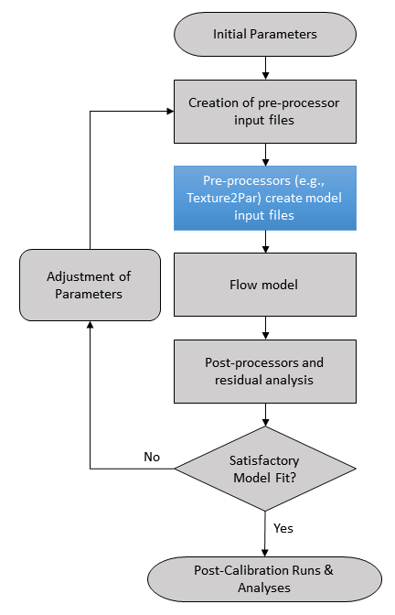

Figure 11 - Simplified Parameter Estimation Workflow

Flow model calibration is generally performed by minimizing the model error when compared against observed historical data (“history matching”). In hydrologic models, these data usually are   
groundwater-level or streamflow measurements. During calibration, the various input parameters to the model are perturbed from a starting value to determine their effect on the model result, as well as the combined effects of correlated parameters. Given that it is unlikely, if even possible, that we know the model-scale aquifer properties at every point in the model domain, these input parameters are often the most obvious candidates for estimation. However, especially for large, complex models, estimating these parameters at every cell or node in the model domain is often an infeasible problem with potentially many non-unique solutions.

Texture2Par’s role in the calibration process is providing a robust way to alter the hydraulic conductivities and storage parameters at nodes/cells of the supported flow models using a parsimonious pilot point setup while also incorporating and honoring textural data. Manipulating the values in the Texture2Par Main Input file, through manual or automated means, can facilitate vast changes in the model flow field and thus the ability of the model to match historical observation data. This is a minor, but important role in the larger calibration process, which can include difficult decisions like which parameters to estimate, the weights assigned to different observations, and even the identification and subsequent correction of errors in the model (Anderson et al., 2015).

The calibration of flow models is nearly always a mathematically ill-posed problem due to there being more unknown model input parameters than field measurements (Freeze and Cherry, 1979). This results in parameter estimation results being non-unique, meaning there is actually an unknown number of parameter sets which equally (or acceptably) fit the observed data. While this poses some philosophical difficulties for the modeler, it also poses some numerical difficulties in the parameter estimation process. For the latter issue, Texture2Par helps by reducing the number of parameters that need to be estimated to approximately ten per pilot point, as opposed to four per model node/cell. Additionally, the accompanying Bond and Durbin (2018) method can be used to estimate those pilot point values, providing context and constraints on what may be considered “reasonable” input values for Texture2Par. The use of these estimated values as constraints on the parameter estimation process is one form of “regularization” (Doherty et al., 2010; Doherty, 2018) that be incorporated in model calibration. With these techniques and sufficient observation data, it is possible to achieve a unique solution to a model calibration problem.

However, it is important to realize that a unique solution does not guarantee a correct solution (Doherty, 2018). A unique solution is still dependent on the formulation of the inverse problem, including the locations of the pilot points, the accuracy of the historical data, the formulation of the objective function, the model temporal and spatial discretization, the boundary conditions, and the model representation of hydrologic processes (Beven, 2005; Doherty and Welter, 2010; Doherty, 2018). Some of these may produce errors that become obvious during calibration and can be corrected (e.g., an outlier in the history matching data) but other errors may simply be invisible and become compensated by other parameters. While model error and “defects” should be minimized to the extent possible prior to and during calibration, the truth is the numerical model itself is an imperfect simplification of reality. In other words, even though we can formulate a *mathematically* unique solution, the solution is still not truly unique: it is the final product created by a series of subjective decisions.

Parameter estimation is but one part of a very complex model creation and calibration process. This is far from a complete guide and the user is encouraged to review the cited material.

## Texture2Par and PEST

PEST is a robust model-independent parameter estimation software suite. Examining the workflow in Figure 11, PEST can take initial parameters, write pre-processor input files (like Texture2Par.in) and run the various pre-processors, models, and post-processors through a windows batch file. When the batch file completes, PEST evaluates the model fit based on residuals and weights of user-supplied calibration targets. By perturbing the values of the selected input parameters, PEST works to minimize these residuals over the course of numerous model runs. To download the software or for more information on PEST and its usage, visit the official website, [www.pesthomepage.org](http://www.pesthomepage.org). Additionally, [GMDSI has a series of video tutorials](http://www.groundwater.com.au/research_projects/groundwater-modelling-decision-support-initiative-gmdsi) by PEST’s author, John Doherty, covering a range of matters related to model calibration theory.

Doherty et al. (2010) provide mathematically-based suggestions for the placement of pilot points. Given that the pilot point parameters for Texture2Par are measurable properties, it is possible to use pilot points to represent field observations. However, given that models are simplifications of complex systems, it may be advisable to instead use these values as regularization constraints for PEST in its estimation of the model parameters. A uniform pattern of pilot points can be a helpful strategy in ensuring coverage over the entire model domain (Anderson et al., 2015). It is acceptable to use pilot points liberally; however, ideally the number of estimated parameters should not exceed the number of observations. Extra pilot points also come with extra computational burden (run times) when kriging aquifer parameter values to nodes/cells, and by adding the number of potential parameters that undergo calibration. Ideally, pilot points are in areas of decent coverage by calibration data.

PEST uses template files to write input files for other programs in the model setup. Figure 12 is an example IWFM Texture2Par main input template file for PEST. This example file features ten pilot points with all parameters (except coordinates and zone) set for PEST estimation, as well as KCk and KFk. The dollar sign ($) is being used as the parameter delimiter, as denoted by the first line of the file after the “ptf” PEST keyword. For readability, the spacing of the parameter space width has been reduced – normally more spaces are included around the parameter name to give PEST more space to write numbers with greater precision (coordinates have also been truncated to a dummy value). The PEST-related entries are shown in blue.

Because Texture2Par is a model pre-processor, it should be included in the PEST model run batch script before the model execution. Figure 13 provides example Windows batch files for IWFM and MODFLOW flow models.

ptf $

*==============================================================================

* Texture2Par Main Input File

*==============================================================================

IWFM / Model Type

welllog.dat / Well Log File

geozones.dat / Geologic Zones File

*------------------------------------------------------------------------------

* Model Settings (IWFM)

*------------------------------------------------------------------------------

Model.in / Simulation File

..\Preproc\Preprocessor.in / Pre-processor File

Model_Groundwater.dat / GW Template File

nodezones.dat / Node Zones File

*------------------------------------------------------------------------------

* Program Settings (True/False)

*------------------------------------------------------------------------------

True / Output Node Files

*------------------------------------------------------------------------------

* Variogram Settings

* itype: 0-linear variogram, 1-spherical variogram, 2-exponential variogram

*------------------------------------------------------------------------------

1 / Variogram Type (itype)

1.0 / Sill

1.0E7 / Range

1.0E7 / Minimum Range

0.0 / Anisotropy Angle (from North)

0.0 / Nugget

16 / Wells used in kriging

*------------------------------------------------------------------------------

* Aquifer Parameter Settings

*------------------------------------------------------------------------------

$ KCk $ / KCk

$ KFk $ / KFk

0.93 / KHp

-0.62 / KVp

1.0 / Syp

*------------------------------------------------------------------------------

* Pilot Points - X Y KCMin deltaKC KFMin deltaKF SsC SsF SyC SyF AnisoC AnisoF Zone

*------------------------------------------------------------------------------

823.0 8954.0 $ KCMin01 $ $ dKC01 $ $ KFMin01 $ $ dKF01 $ $ SsC01 $ $ SsF01 $ $ SyC01 $ $ SyF01 $ $ aC01 $ $ aF01 $ 1

823.0 8954.0 $ KCMin02 $ $ dKC02 $ $ KFMin02 $ $ dKF02 $ $ SsC02 $ $ SsF02 $ $ SyC02 $ $ SyF02 $ $ aC02 $ $ aF02 $ 1

936.0 8034.0 $ KCMin03 $ $ dKC03 $ $ KFMin03 $ $ dKF03 $ $ SsC03 $ $ SsF03 $ $ SyC03 $ $ SyF03 $ $ aC03 $ $ aF03 $ 1

936.0 8034.0 $ KCMin04 $ $ dKC04 $ $ KFMin04 $ $ dKF04 $ $ SsC04 $ $ SsF04 $ $ SyC04 $ $ SyF04 $ $ aC04 $ $ aF04 $ 1

049.0 7115.0 $ KCMin05 $ $ dKC05 $ $ KFMin05 $ $ dKF05 $ $ SsC05 $ $ SsF05 $ $ SyC05 $ $ SyF05 $ $ aC05 $ $ aF05 $ 1

049.0 7115.0 $ KCMin06 $ $ dKC06 $ $ KFMin06 $ $ dKF06 $ $ SsC06 $ $ SsF06 $ $ SyC06 $ $ SyF06 $ $ aC06 $ $ aF06 $ 1

996.0 2793.0 $ KCMin07 $ $ dKC07 $ $ KFMin07 $ $ dKF07 $ $ SsC07 $ $ SsF07 $ $ SyC07 $ $ SyF07 $ $ aC07 $ $ aF07 $ 1

162.0 6195.0 $ KCMin08 $ $ dKC08 $ $ KFMin08 $ $ dKF08 $ $ SsC08 $ $ SsF08 $ $ SyC08 $ $ SyF08 $ $ aC08 $ $ aF08 $ 1

274.0 5276.0 $ KCMin09 $ $ dKC09 $ $ KFMin09 $ $ dKF09 $ $ SsC09 $ $ SsF09 $ $ SyC09 $ $ SyF09 $ $ aC09 $ $ aF09 $ 1

274.0 5276.0 $ KCMin10 $ $ dKC10 $ $ KFMin10 $ $ dKF10 $ $ SsC10 $ $ SsF10 $ $ SyC10 $ $ SyF10 $ $ aC10 $ $ aF10 $ 1

*------------------------------------------------------------------------------

* Aquitard Pilot Points - X Y KCMin deltaKC KFMin deltaKF AnisoC AnisoF Zone

*------------------------------------------------------------------------------

823.0 8954.0 $ KCMin11 $ $ dKC11 $ $ KFMin11 $ $ dKF11 $ $ aC11 $ $ aF11 $ 1

823.0 8954.0 $ KCMin12 $ $ dKC12 $ $ KFMin12 $ $ dKF12 $ $ aC12 $ $ aF12 $ 1

936.0 8034.0 $ KCMin13 $ $ dKC13 $ $ KFMin13 $ $ dKF13 $ $ aC13 $ $ aF12 $ 1

936.0 8034.0 $ KCMin14 $ $ dKC14 $ $ KFMin14 $ $ dKF14 $ $ aC14 $ $ aF14 $ 1

*------------------------------------------------------------------------------

* EOF

*------------------------------------------------------------------------------

Figure - Example Texture2Par (IWMF) PEST Template File

@echo off

:: Run Texture2Par

Texture2Par.exe

:: Run Model

..\bin\Simulation2015_x64.exe MyIWFMSim.in

:: Rest of batch file (post-processors, etc…)

iwfm2obs.exe < iwfm2obs.in

@echo off

:: Run Texture2Par

Texture2Par.exe

:: Run Model

MF2005.exe MyMFSim.nam

:: Rest of batch file (post-processors, etc…)

HeadsAtWells.exe HeadsAtWells.in

Figure - Example Batch Files for IWFM (Top) and MODFLOW (Bottom) for Running Texture2Par with PEST

# References

Anderson, M.P., W.W. Woessner, and R.J. Hunt. 2015. *Applied Groundwater Modeling.* 2nd Edition. Elsevier.

Beven, K. 2005. *On the Concept of Model Structural Error.* Water Science & Technology 52 (6): 167–75. <https://iwaponline.com/wst/article-pdf/52/6/167/434056/167.pdf>.

Blöschl, G., and M. Sivapalan. 1995. *Scale issues in hydrological modelling: A review.* Hydrological Processes 9, no. 3–4: 251–290. <https://doi.org/10.1002/hyp.3360090305>.

Bond, L., and T.J. Durbin. 2018. *Sacramento Valley Groundwater-Surface Water Simulation Model Technical Memorandum 1B (SVSim TM-1B)*. Sacramento, California.

Burow K.R., J.L. Shelton, J.A. Hevesi, and G.S. Weissmann. 2004. *Hydrogeologic characterization of the Modesto area, San Joaquin Valley, California*. U.S. Geological Survey Scientific Investigations Report 2004-5232, 54 pp.

Cardwell, W.T., and R.L. Parsons. 1945. Average Permeabilities of Heterogeneous Oil Sands. *Transactions of the AIME* 160, no. 01: 34-42, <https://doi.org/10.2118/945034-g>.

Davis, G.H., J.H. Green, F.H. Olmsted, and D.W. Brown. 1959. *Ground-Water Conditions and Storage Capacity in the San Joaquin Valley, California*: U.S. Geological Survey Water-Supply Paper 1469. <https://pubs.er.usgs.gov/publication/wsp1469>.

Davis, G.H., B.E. Lofgren, and S. Mack. 1964. *Use of Ground-Water Reservoirs for Storage of Surface Water in the San Joaquin Valley, California*: U.S. Geological Survey Water-Supply Paper 1618. <https://pubs.er.usgs.gov/publication/wsp1618>.

Deutsch, C. V., and A. G. Journel. 1998. *GSLIB: Geostatistical Software Library and User’s Guide*. Second. Oxford University Press.

Dogrul, E.C., T.N. Kadir, and C.F. Brush. 2018. *Integrated Water Flow Model Theoretical Documentation*. Bay-Delta Office, California Department of Water Resources. Sacramento, CA.

Doherty, J.E. 2018. *PEST: Model-Independent Parameter Estimation*. User Manual. <http://www.pesthomepage.org>.

Doherty, J.E., M.N. Fienen, and R.J. Hunt. 2010. *Approaches to Highly Parameterized Inversion: Pilot-Point Theory, Guidelines, and Research Directions*. U.S. Geological Survey Scientific Investigations Report 2010-5168.

Doherty, J., and D. Welter. 2010. *A Short Exploration of Structural Noise.* *Water Resources Research* 46, no. 5: W05525. <https://doi.org/10.1029/2009WR008377>.

Durbin, T.J., G.W. Kapple, and J.R. Freckleton. 1978. *Two-Dimensional and Three-Dimensional Digital Flow Models of the Salinas Valley Ground-Water Basin, California*. USGS Water-Resources Investigations Report 78-113.

Faunt, C. 2009. *Groundwater Availability of the Central Valley Aquifer, California*: U.S. Geological Survey Professional Paper 1766. <https://pubs.usgs.gov/pp/1766/PP_1766.pdf>.

Faunt, C.C., K. Belitz, and R.T. Hanson. 2010. *Development of a Three-Dimensional Model of Sedimentary Texture in Valley-Fill Deposits of Central Valley, California, USA.* *Hydrogeology Journal* 18, no. 3: 625-649. <https://ca.water.usgs.gov/projects/central-valley/HydrogeologyJournal-2010-18.pdf>.

Freeze, R.A., and J.A. Cherry. 1979. *Groundwater*. Englewood Cliffs, NJ: Prentice-Hall, Inc.

Harbaugh, A.W. 2005. *MODFLOW-2005, The U.S. Geological Survey Modular Ground-Water Model-the Ground-Water Flow Process*: U.S. Geological Survey Techniques and Methods 6-A16.

Harbaugh, A.W., E.R. Banta, M.C. Hill, and M.G. McDonald. 2000. *MODFLOW-2000, The U.S. Geological Survey Modular Ground-Water Model - User Guide to Modularization Concepts and the Ground-Water Flow Process*: U.S. Geological Survey Open-File Report 00-92. <https://water.usgs.gov/nrp/gwsoftware/modflow2000/ofr00-92.pdf>.

Helley, E.J., and D.S. Harwood. 1985. Geologic Map of the Late Cenozoic Deposits of the Sacramento Valley and Northern Sierra Foothills, California: U.S. Geological Survey Miscellaneous Field Studies Map MF-1790. 24 p.

Laudon, J., and K. Belitz. 1989. *Texture and Depositional History of Near-Surface Alluvial Deposits in the Central Part of the Western San Joaquin Valley, California*: U.S. Geological Survey Open-File Report 89-235. <https://pubs.usgs.gov/of/1989/0235/report.pdf>.

Laudon, J., and K. Belitz. 1991. Texture and Depositional History of Late Pleistocene-Holocene Alluvium in the Central Part of the Western San Joaquin Valley, California. *Environmental & Engineering Geoscience* xxviii, no. 1: 73–88. <https://pubs.geoscienceworld.org/eeg/article/xxviii/1/73-88/137461>.

Loquin, K., and D. Dubois. 2010. *Kriging and Epistemic Uncertainty: A Critical Discussion.* In Methods for Handling Imperfect Spatial Information (pp. 269–305). Springer, Berlin, Heidelberg. <https://doi.org/10.1007/978-3-642-14755-5_11>.

Mulder, J. 2015. Geologic Map of the Sacramento Valley - Helley and Harwood Map Book: California Department of Water Resources.

National Resources Conservation Service. 2016. Soil survey geographic (SSURGO) database:  <https://websoilsurvey.nrcs.usda.gov/>.

Niswonger, R.G., S. Panday, and M. Ibaraki. 2011. *MODFLOW-NWT, A Newton Formulation for MODFLOW-2005*: U.S. Geological Survey Techniques and Methods 6–A37. <https://pubs.usgs.gov/tm/tm6a37/pdf/tm6a37.pdf>.

Page, R.W. 1983. *Geology of the Tulare formation and other continental deposits, Kettleman City area, San Joaquin Valley, California, with a section on ground-water management considerations and use of texture maps.* U.S. Geological Survey Water-Resources Investigations Report 83–4000, 24 pp.

Page, R.W. 1986. *Geology of the Fresh Ground-Water Basin of the Central Valley, California, with Texture Maps and Sections*: U.S. Geological Survey Professional Paper 1401-C. <https://pubs.usgs.gov/pp/1401c/report.pdf>.

Phillips, S.P., and K. Belitz. 1991. Calibration of a Texture-Based Model of a Ground-Water Flow System, Western San Joaquin Valley, California*.* *Ground Water* 29, no. 5: 702–15. <http://doi.wiley.com/10.1111/j.1745-6584.1991.tb00562.x>.

U.S.Geological Survey. 2013. *Basic Package Input Instructions*. <https://water.usgs.gov/nrp/gwsoftware/modflow2000/MFDOC/index.html?bas6.htm> (Accessed November 28, 2018).

Wagner, D.L., and E.J. Bortugno. 1982. Geologic Map of the Santa Rosa Quadrangle: California Geological Survey, Regional Geologic Map No. 2A, 1:250,000 scale. <https://www.conservation.ca.gov/cgs/Documents/Publications/Regional-Geologic-Maps/RGM_002A/RGM_002A_SantaRosa_1982_Sheet1of5.pdf>.

Wagner, D.L., E.J. Bortugno, and R.D. McJunkin. 1991. Geologic Map of the San Francisco – San Jose Quadrangle: California Geological Survey, Regional Geologic Map No. 5A, 1:250,000 scale. [https://www.conservation.ca.gov/cgs/Documents/Publications/Regional-Geologic-Maps/RGM_005A/RGM_005A_SanFrancisco-SanJose_1991_Sheet1of5.pdf](https://www.conservation.ca.gov/cgs/Documents/Publications/Regional-Geologic-Maps/RGM_005A/RGM_005A_SanFrancisco-SanJose_1991_Sheet1of5.pdf%20).

Wagner, D.L., C.W. Jennings, T.L. Bedrossian, and E.J. Bortugno. 1981. Geologic Map of the Sacramento Quadrangle: California Geological Survey, Regional Geologic Map No. 1A, 1:250,000 scale. [https://www.conservation.ca.gov/cgs/Documents/Publications/Regional-Geologic-Maps/RGM_001A/RGM_001A_Sacramento_1981_Sheet1of4.pdf](https://www.conservation.ca.gov/cgs/Documents/Publications/Regional-Geologic-Maps/RGM_001A/RGM_001A_Sacramento_1981_Sheet1of4.pdf%20).

Wen, X.-H., and J.J. Gómez-Hernández. 1996. *Upscaling Hydraulic Conductivities in Heterogeneous Media: An Overview.* *Journal of Hydrology* 183, no. 1-2: ix-xxxii. <https://doi.org/10.1016/s0022-1694(96)80030-8>.

Zanon, S., H. Nguyen, and C. V. Deutsch. 2002. Power Law Averaging Revisited. Center for Computational Geostatistics Annual Report Papers, 1–29.